JL Precision

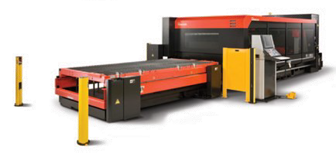
Shear, Punch, Laser and Forming Equipment:
Laser Cutters (x3) Turret Punches (x3) Press Brakes (x9) Rollers (x2)
Shears / Saws

Milling and Turning Equipment:
4-Axis CNC Horizontals (x2) Verticals CNC (x9)
CNC Lathes (x2) Manual Equipment

AMADA FOM2 3015 NT
4KW laser cuts 0.875” CRS
0.5” SS, 0.375” Al

AMADA EMK 3610NT
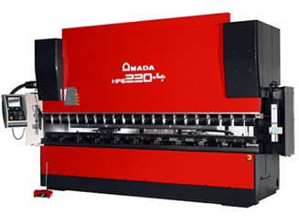
600 ton press brake, bends up to 23’

Welding
MIG
TIG
Structural Framing

Quick Turn Finishing and Plating
Anodize: Type II and III
Alodine: Clear, Gold, and Chrome-Free Nickel: Bright and Electroless Passivation
Zinc: Clear and Gold

HAAS VF11
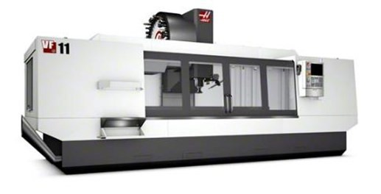
120” x 42” x 35” table

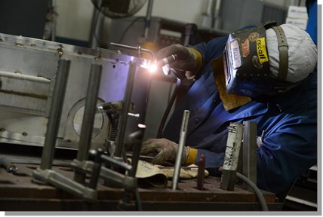
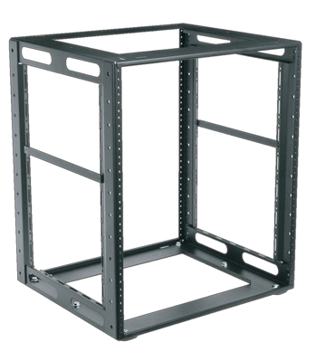

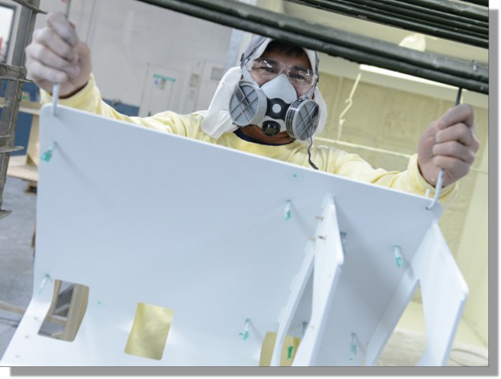
Painting and Surface Preparation
Bead Blast Powder Coating Wet Painting Silk Screening

