**PVD coated colored stainless steel standard colors**

[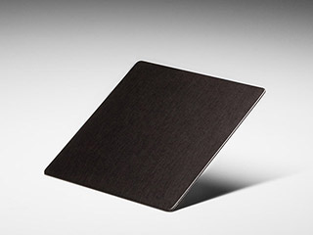](https://www.johndesmond.com/wp-content/themes/john-desmond/images/samples/lrg/black-is-black-vibration.jpg)

Black Is Black Vibration

[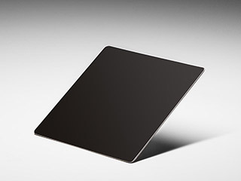](https://www.johndesmond.com/wp-content/themes/john-desmond/images/samples/lrg/black-is-black-mirror-finish.jpg)

Black Is Black Mirror Finish

[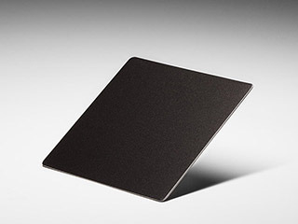](https://www.johndesmond.com/wp-content/themes/john-desmond/images/samples/lrg/black-is-black-sandblasted.jpg)

Black Is Black Sandblasted

[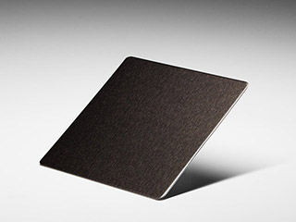](https://www.johndesmond.com/wp-content/themes/john-desmond/images/samples/lrg/black-is-black-brush.jpg)

Black Is Black Brush

[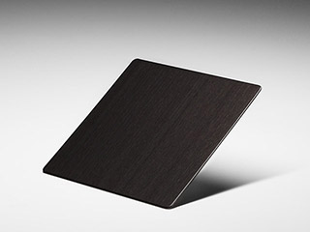](https://www.johndesmond.com/wp-content/themes/john-desmond/images/samples/lrg/black-is-black-hairline.jpg)

Black Is Black Hairline

[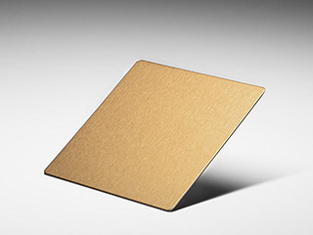](https://www.johndesmond.com/wp-content/themes/john-desmond/images/samples/lrg/brass-brush.jpg)

Brass Brush

[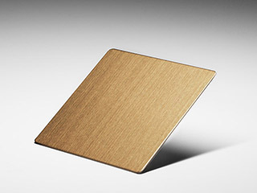](https://www.johndesmond.com/wp-content/themes/john-desmond/images/samples/lrg/brass-hairline.jpg)

Brass Hairline

[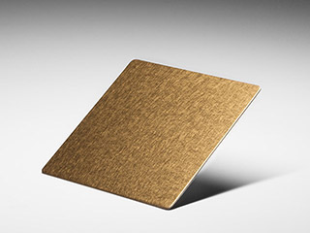](https://www.johndesmond.com/wp-content/themes/john-desmond/images/samples/lrg/brass-vibration.jpg)

Brass Vibration

[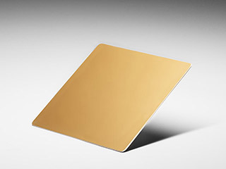](https://www.johndesmond.com/wp-content/themes/john-desmond/images/samples/lrg/brass-mirror-finish.jpg)

Brass Mirror Finish

[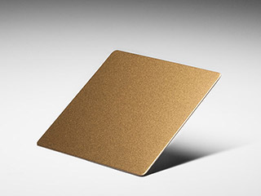](https://www.johndesmond.com/wp-content/themes/john-desmond/images/samples/lrg/brass-sandblasted.jpg)

Brass Sandblasted

[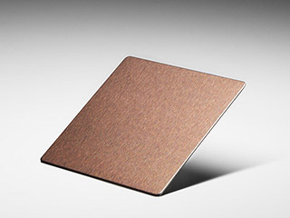](https://www.johndesmond.com/wp-content/themes/john-desmond/images/samples/lrg/bronze-brush.jpg)

Bronze Brush

[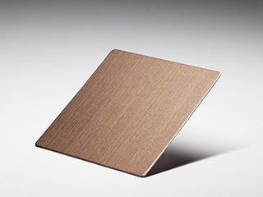](https://www.johndesmond.com/wp-content/themes/john-desmond/images/samples/lrg/bronze-hairline.jpg)

Bronze Hairline

[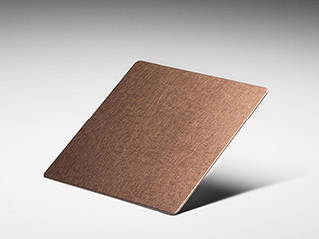](https://www.johndesmond.com/wp-content/themes/john-desmond/images/samples/lrg/bronze-vibration.jpg)

Bronze Vibration

[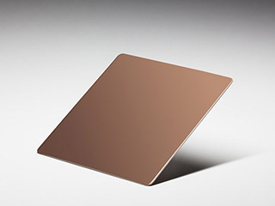](https://www.johndesmond.com/wp-content/themes/john-desmond/images/samples/lrg/bronze-mirror-finish.jpg)

Bronze Mirror Finish

[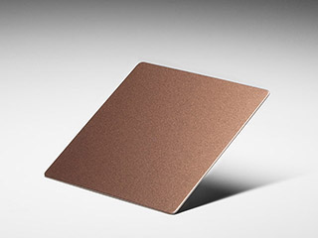](https://www.johndesmond.com/wp-content/themes/john-desmond/images/samples/lrg/bronze-sandblasted.jpg)

Bronze Sandblasted

[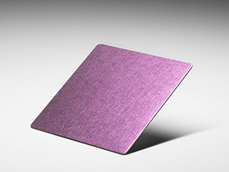](https://www.johndesmond.com/wp-content/themes/john-desmond/images/samples/lrg/candy-pink-vibration.jpg)

Candy Pink Vibration

[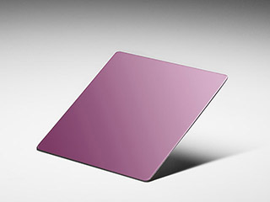](https://www.johndesmond.com/wp-content/themes/john-desmond/images/samples/lrg/candy-pink-mirror-finish.jpg)

Candy Pink Mirror Finish

[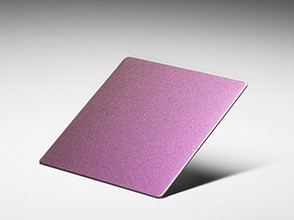](https://www.johndesmond.com/wp-content/themes/john-desmond/images/samples/lrg/candy-pink-sandblasted.jpg)

Candy Pink Sandblasted

[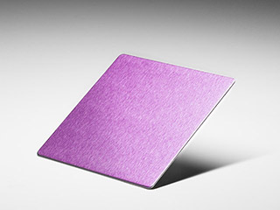](https://www.johndesmond.com/wp-content/themes/john-desmond/images/samples/lrg/candy-pink-brush.jpg)

Candy Pink Brush

[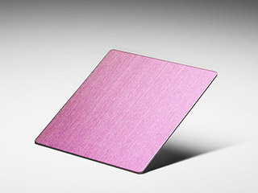](https://www.johndesmond.com/wp-content/themes/john-desmond/images/samples/lrg/candy-pink-hairline.jpg)

Candy Pink Hairline

[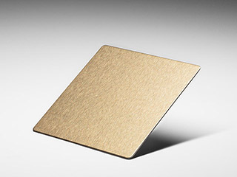](https://www.johndesmond.com/wp-content/themes/john-desmond/images/samples/lrg/champagne-brush.jpg)

Champagne Brush

[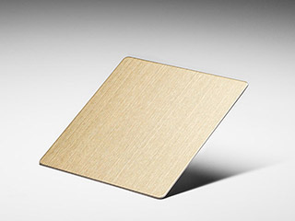](https://www.johndesmond.com/wp-content/themes/john-desmond/images/samples/lrg/champagne-hairline.jpg)

Champagne Hairline

[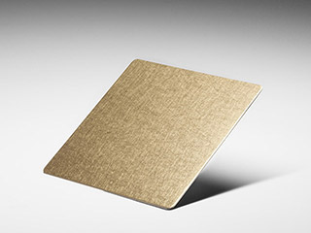](https://www.johndesmond.com/wp-content/themes/john-desmond/images/samples/lrg/champagne-vibration.jpg)

Champagne Vibration

[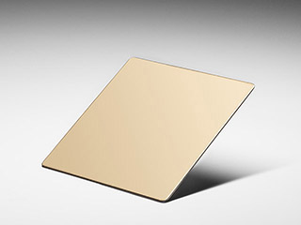](https://www.johndesmond.com/wp-content/themes/john-desmond/images/samples/lrg/champagne-mirror-finish.jpg)

Champagne Mirror Finish

[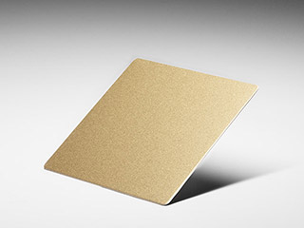](https://www.johndesmond.com/wp-content/themes/john-desmond/images/samples/lrg/champagne-sandblasted.jpg)

Champagne Sandblasted

[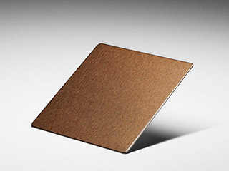](https://www.johndesmond.com/wp-content/themes/john-desmond/images/samples/lrg/chocolate-brush.jpg)

Chocolate Brush

[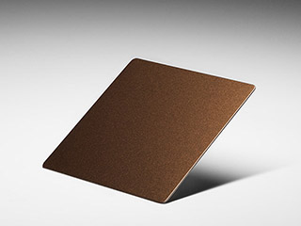](https://www.johndesmond.com/wp-content/themes/john-desmond/images/samples/lrg/chocolate-sandblasted.jpg)

Chocolate Sandblasted

[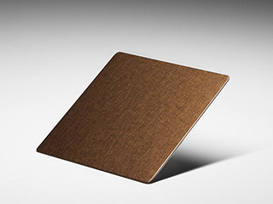](https://www.johndesmond.com/wp-content/themes/john-desmond/images/samples/lrg/chocolate-vibration.jpg)

Chocolate Vibration

[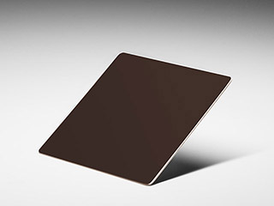](https://www.johndesmond.com/wp-content/themes/john-desmond/images/samples/lrg/chocolate-mirror-finish.jpg)

Chocolate Mirror Finish

[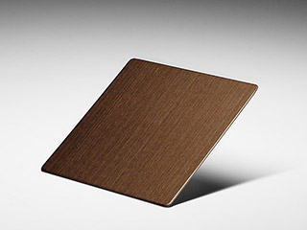](https://www.johndesmond.com/wp-content/themes/john-desmond/images/samples/lrg/chocolate-hairline.jpg)

Chocolate Hairline

[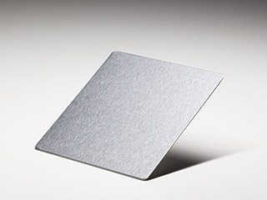](https://www.johndesmond.com/wp-content/themes/john-desmond/images/samples/lrg/chrome-brush.jpg)

Chrome Brush

[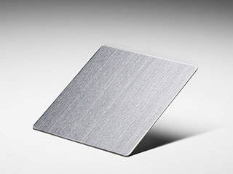](https://www.johndesmond.com/wp-content/themes/john-desmond/images/samples/lrg/chrome-hairline.jpg)

Chrome Hairline

[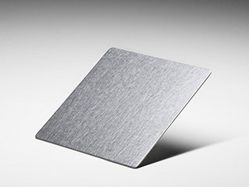](https://www.johndesmond.com/wp-content/themes/john-desmond/images/samples/lrg/chrome-vibration.jpg)

Chrome Vibration

[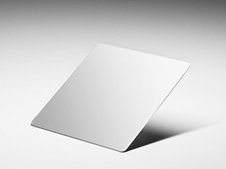](https://www.johndesmond.com/wp-content/themes/john-desmond/images/samples/lrg/chrome-mirror-finish.jpg)

Chrome Mirror Finish

[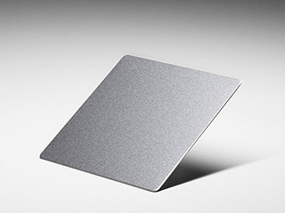](https://www.johndesmond.com/wp-content/themes/john-desmond/images/samples/lrg/chrome-sandblasted.jpg)

Chrome Sandblasted

[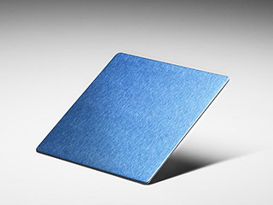](https://www.johndesmond.com/wp-content/themes/john-desmond/images/samples/lrg/cobolt-brush.jpg)

Cobalt Brush

[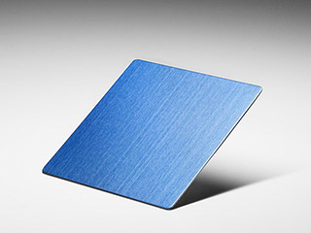](https://www.johndesmond.com/wp-content/themes/john-desmond/images/samples/lrg/cobolt-hairline.jpg)

Cobalt Hairline

[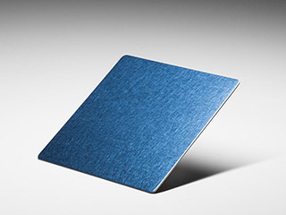](https://www.johndesmond.com/wp-content/themes/john-desmond/images/samples/lrg/cobolt-vibration.jpg)

Cobalt Vibration

[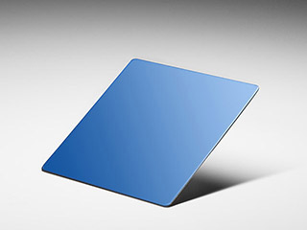](https://www.johndesmond.com/wp-content/themes/john-desmond/images/samples/lrg/cobalt-blue-mirror-finish.jpg)

Cobalt Blue Mirror Finish

[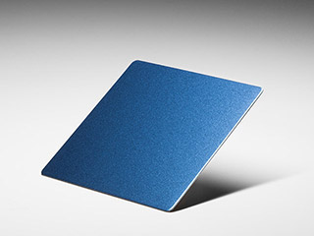](https://www.johndesmond.com/wp-content/themes/john-desmond/images/samples/lrg/coblt-sandblasted.jpg)

Cobalt Sandblasted

[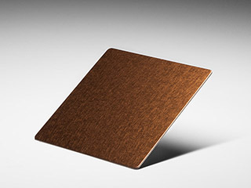](https://www.johndesmond.com/wp-content/themes/john-desmond/images/samples/lrg/copper-vibration.jpg)

Copper Vibration

[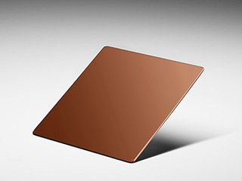](https://www.johndesmond.com/wp-content/themes/john-desmond/images/samples/lrg/copper-mirror-finish.jpg)

Copper Mirror Finish

[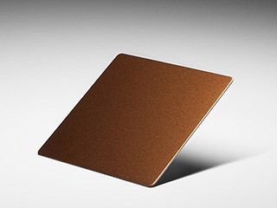](https://www.johndesmond.com/wp-content/themes/john-desmond/images/samples/lrg/copper-sandblasted.jpg)

Copper Sandblasted

[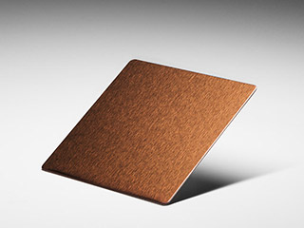](https://www.johndesmond.com/wp-content/themes/john-desmond/images/samples/lrg/copper-brush.jpg)

Copper Brush

[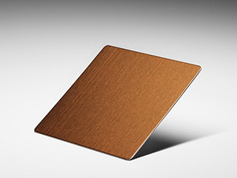](https://www.johndesmond.com/wp-content/themes/john-desmond/images/samples/lrg/copper-hairline.jpg)

Copper Hairline

[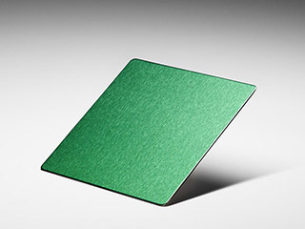](https://www.johndesmond.com/wp-content/themes/john-desmond/images/samples/lrg/emerald-brush.jpg)

Emerald Brush

[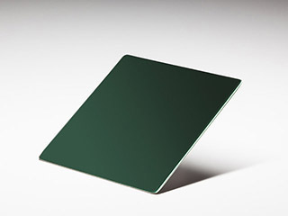](https://www.johndesmond.com/wp-content/themes/john-desmond/images/samples/lrg/emarald-mirror-finish.jpg)

Emerald Mirror Finish

[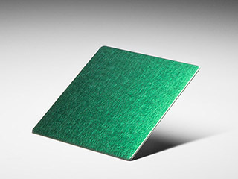](https://www.johndesmond.com/wp-content/themes/john-desmond/images/samples/lrg/emerald-vibration.jpg)

Emerald Vibration

[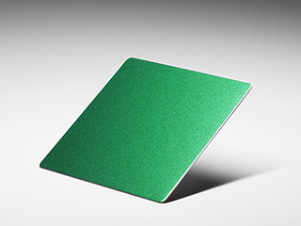](https://www.johndesmond.com/wp-content/themes/john-desmond/images/samples/lrg/emerald-sandblast.jpg)

Emerald Sandblast

[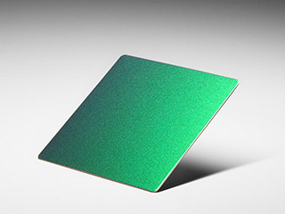](https://www.johndesmond.com/wp-content/themes/john-desmond/images/samples/lrg/emerald-hairline.jpg)

Emerald Hairline

[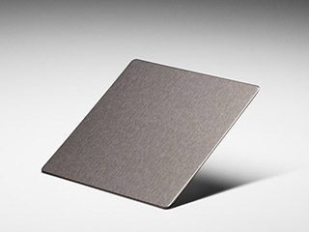](https://www.johndesmond.com/wp-content/themes/john-desmond/images/samples/lrg/gun-metal-brush.jpg)

Gun Metal Brush

[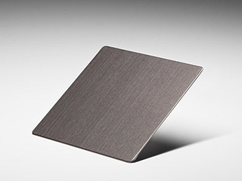](https://www.johndesmond.com/wp-content/themes/john-desmond/images/samples/lrg/gun-metal-hairline.jpg)

Gun Metal Hairline

[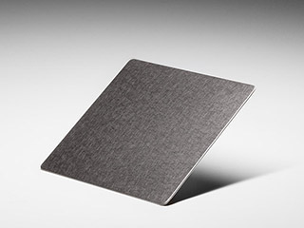](https://www.johndesmond.com/wp-content/themes/john-desmond/images/samples/lrg/gun-metal-vibration.jpg)

Gun Metal Vibration

[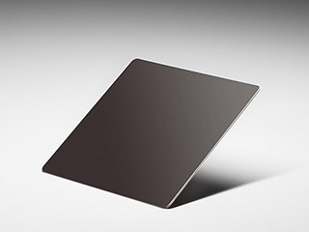](https://www.johndesmond.com/wp-content/themes/john-desmond/images/samples/lrg/gun-metal-mirror-finish.jpg)

Gun Metal Mirror Finish

[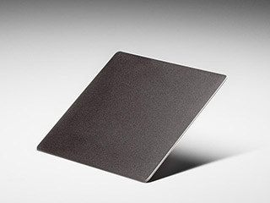](https://www.johndesmond.com/wp-content/themes/john-desmond/images/samples/lrg/gun-metal-sandblasted.jpg)

Gun Metal Sandblasted

[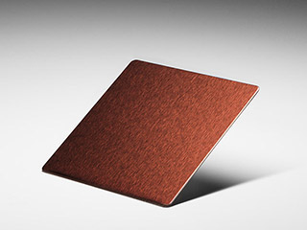](https://www.johndesmond.com/wp-content/themes/john-desmond/images/samples/lrg/red-bronze-brush.jpg)

Red Bronze Brush

[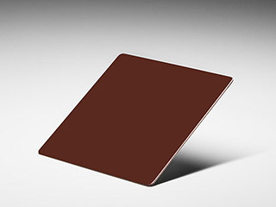](https://www.johndesmond.com/wp-content/themes/john-desmond/images/samples/lrg/red-bronze-mirror-finish.jpg)

Red Bronze Mirror Finish

[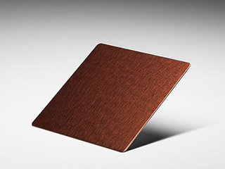](https://www.johndesmond.com/wp-content/themes/john-desmond/images/samples/lrg/red-bronze-vibration.jpg)

Red Bronze Vibration

[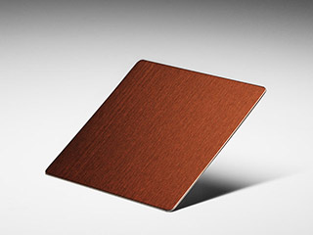](https://www.johndesmond.com/wp-content/themes/john-desmond/images/samples/lrg/red-bronze-hairline.jpg)

Red Bronze Hairline

[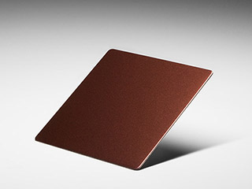](https://www.johndesmond.com/wp-content/themes/john-desmond/images/samples/lrg/red-bronze-sandblasted.jpg)

Red Bronze Sandblasted

[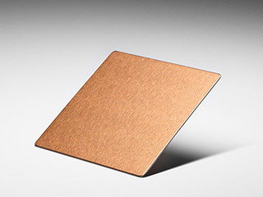](https://www.johndesmond.com/wp-content/themes/john-desmond/images/samples/lrg/rose-brush.jpg)

Rose Gold Brush

[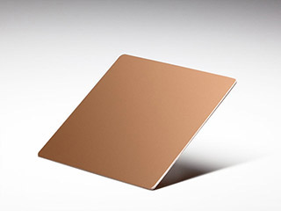](https://www.johndesmond.com/wp-content/themes/john-desmond/images/samples/lrg/rose-mirror-finish.jpg)

Rose Gold Mirror Finish

[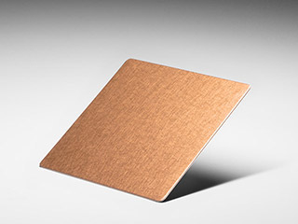](https://www.johndesmond.com/wp-content/themes/john-desmond/images/samples/lrg/rose-vibration.jpg)

Rose Gold Vibration

[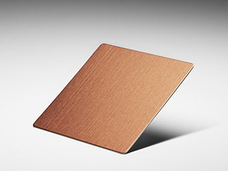](https://www.johndesmond.com/wp-content/themes/john-desmond/images/samples/lrg/rose-hairline-finish.jpg)

Rose Gold Hairline

[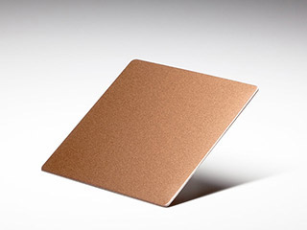](https://www.johndesmond.com/wp-content/themes/john-desmond/images/samples/lrg/rose-sandblasted.jpg)

Rose Gold Sandblasted

[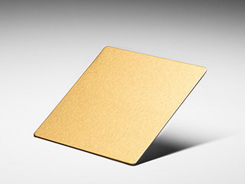](https://www.johndesmond.com/wp-content/themes/john-desmond/images/samples/lrg/royal-gold-brush.jpg)

Royal Gold Brush

[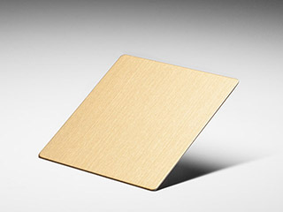](https://www.johndesmond.com/wp-content/themes/john-desmond/images/samples/lrg/royal-gold-hairline.jpg)

Royal Gold Hairline

[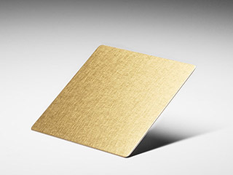](https://www.johndesmond.com/wp-content/themes/john-desmond/images/samples/lrg/royal-gold-vibration.jpg)

Royal Gold Vibration

[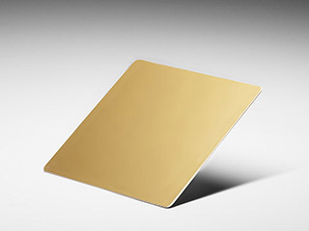](https://www.johndesmond.com/wp-content/themes/john-desmond/images/samples/lrg/royal-gold-mirror-finish.jpg)

Royal Gold Mirror Finish

[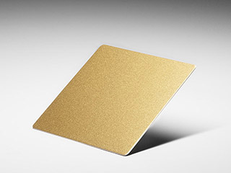](https://www.johndesmond.com/wp-content/themes/john-desmond/images/samples/lrg/royal-gold-sandblasted.jpg)

Royal Gold Sandblasted

[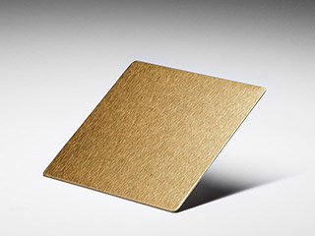](https://www.johndesmond.com/wp-content/themes/john-desmond/images/samples/lrg/vegas-gold-brush.jpg)

Vegas Gold Brush

[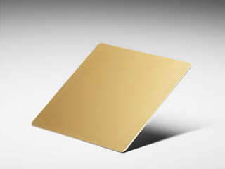](https://www.johndesmond.com/wp-content/themes/john-desmond/images/samples/lrg/vegas-gold-mirror-finish.jpg)

Vegas Gold Mirror Finish

[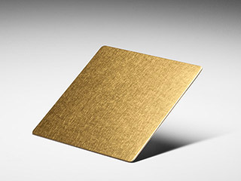](https://www.johndesmond.com/wp-content/themes/john-desmond/images/samples/lrg/vegas-gold-vibration.jpg)

Vegas Gold Vibration

[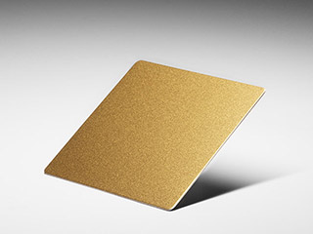](https://www.johndesmond.com/wp-content/themes/john-desmond/images/samples/lrg/vegas-gold-sandblasted.jpg)

Vegas Gold Sandblasted

[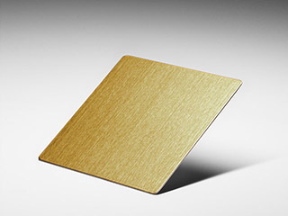](https://www.johndesmond.com/wp-content/themes/john-desmond/images/samples/lrg/vegas-gold-hairline.jpg)

Vegas Gold Hairline