Sample colors shown may be affected by the type of monitor or printer used.

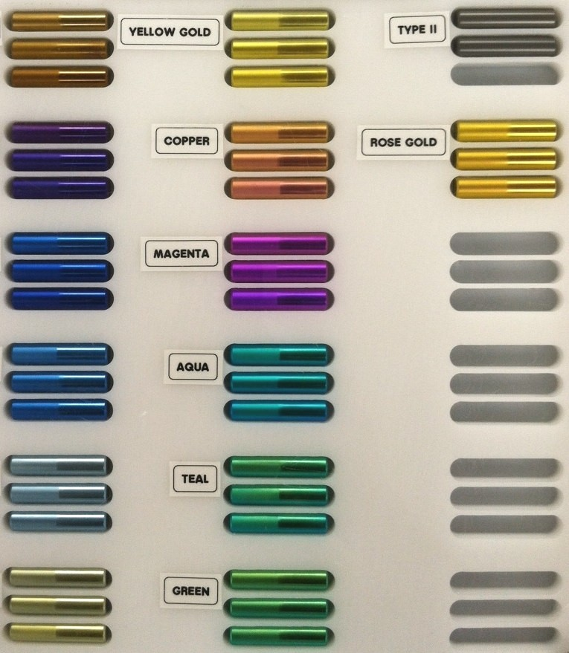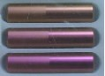EC0-002

EC0-007
Gold

Type II Grey To AMS 2488
Bronze

EC0-003

EC0-019
Pink

EC0-008
Rose Gold
Purple

EC0-004

EC0-009
Magenta
Dark Blue

EC0-015
Aqua

EC0-005
Medium Blue

EC0-014
light Blue

EC0-006
Seafoam

EC0-011

EC0-010
Teal
Green

Colors with Red Text are not available with CP Grade 2 Titanium

For the full spectrum of colors use
Grade 5, 6Al-4V Titanium

